**01. Vertical Pod Autoscaler - Introduction**

--- in this section, we are going to understand about vertical pod auto scalars related auto scaling concept.

**VPA – introduction**

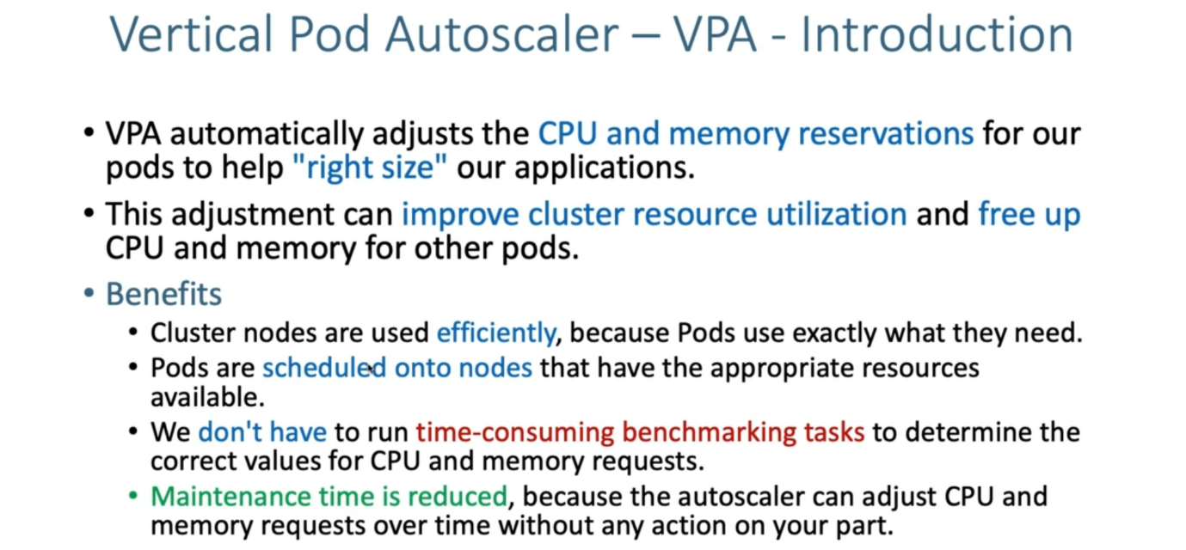

**VPA components**

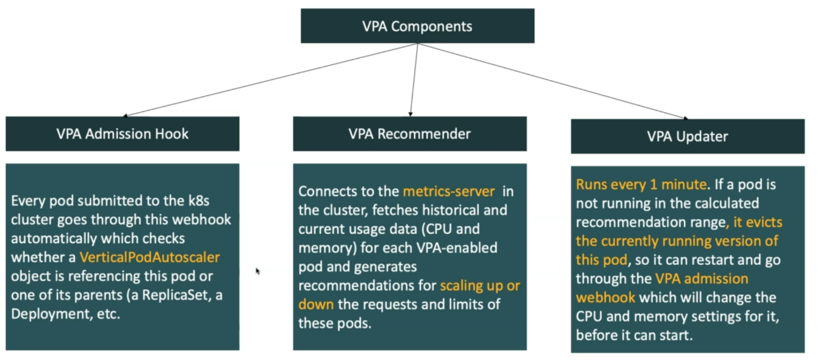

--- we have three types of VPA components available, which means VPA is not out of the box available. Unlike her HPA in kubernetes resources.

--- VPA is an additional resource, we need to install that in your kubernetes.

--- as part of that installation. we are going to get three components from VPA side.

* VPA admission hook,
* VPA recommender
* VPN updater.